TEAM 1-K15T1-VANLANGUNI
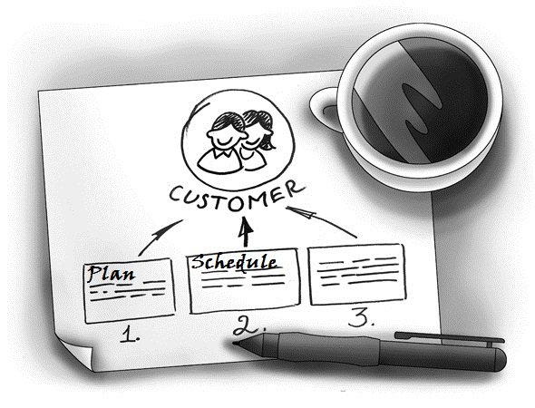
SOFTWARE REQUIREMENT SPECIFICATION
Meeting Room Booking System (MRBS)
Ver0.1
Create by: Van Le
12/6/12

[Internal document circulated and do not copy]

Team Members:
- Le Dinh Thach Huyen (Member)
- Dang Huy Son (Technical Researcher)
- Do Minh Tam (Technical Researcher & Recorder)
- Nguyen Trung Tin (Member)
- Dang Nguyen Toan (Members)
- Le Thi Bich Van (Project Manager)
Abstract:
Room Meeting Booking System is program management room meeting of IT department of Van Lang University. This document describes the requirements for the Room Meeting Booking System product
Revision History
Content | Date | Author | Version
Define template and main contents | 6/12/12 | Van Le | Ver0.1

Table of contents
List of figure
List of table

- Overview

